**DU Data Analytics Bootcamp : Project 1**

By: Brandon Kaus, Chris Marchetti, Alex Monts

& Kiet Tung

How does money change the world? Our project attempts to gain insights into this question, and the questions listed below, by looking for links between GDP, U.S. Foreign Aid, World Bank Aid and the Human Development Index (HDI):

1. Does foreign aid affect a country’s standard of living?

2. Does foreign aid impact GDP?

3. What are the sources of US foreign aid ?

4. Does the type of aid impact HDI or GDP?

We found time series data sets data from the World Bank, US Foreign Aid, United Nations and **GDP** to begin our analysis. After reviewing the data sets, we established a strategy for cleaning the data. The first step was to use the same timespan and countries within each data set. Next we used splits and strips to normalize the country naming conventions used in each dataset. Lastly, we dropped blank columns and replaced “NANs” and “INFs” with 0s. We recognize that replacing “NANs” and “INFs” with 0 distorts our data, but time limitations warranted this decision, and the distortions would likely underestimate correlation.

**Does foreign aid affect a country’s standard of living?**

This was the cornerstone to our research. From the visualizations and statistical testing we could not conclude that there was a strong correlation between foriegn aid received from the U.S and other World donors like the IMF and an increase in the HDI or GDP.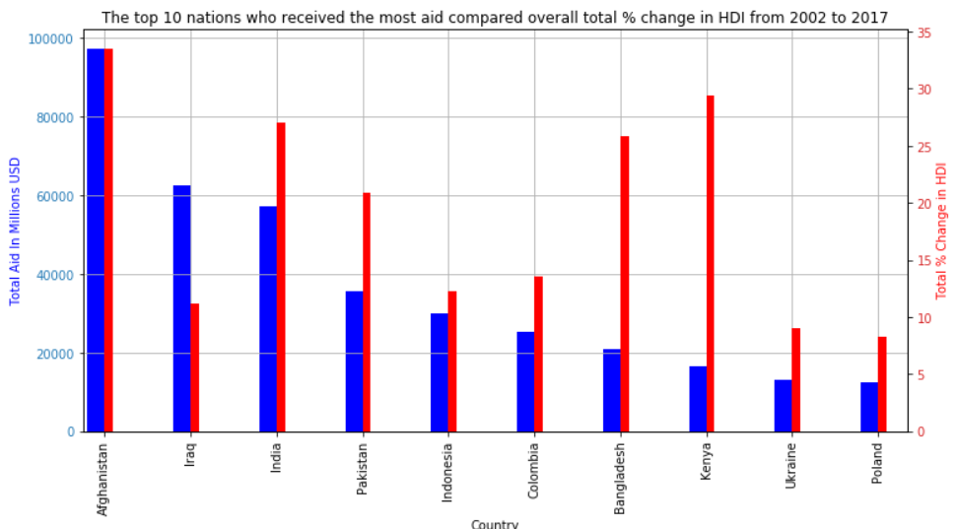

The above chart illustrates the relationship between Total Aid given and total percent change in the HDI over a 15 year period. As you can see as the amount of aid goes down there is no indication that the percent change in HDI is following that trend. This suggests that in order to find an accurate conclusion we must look at these countries and aid totals on a case by case basis. More specifically it is important to delve deeper into the type of Aid that is being distributed.

**Does foreign aid impact GDP?**

To Answer our next question we followed the same process as before when analyzing the correlation for HDI.

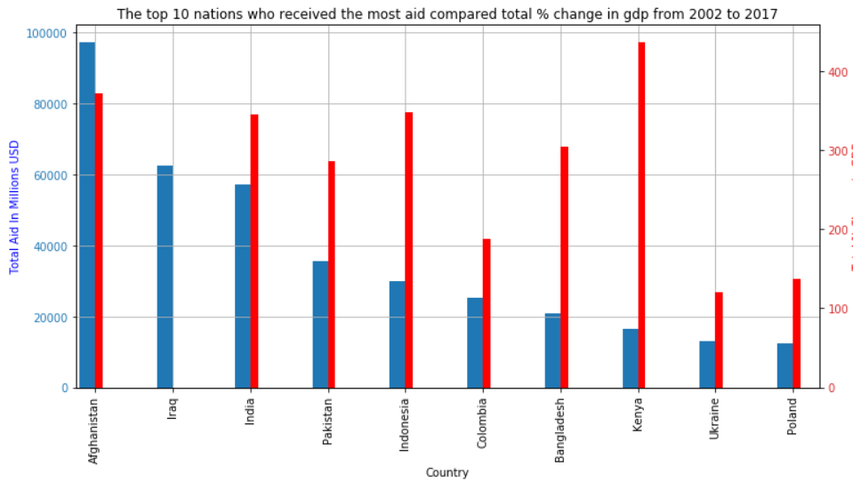

The above chart looks at total Aid given(blue) and percent change in GDP(red). The chart is very similar to the HDI chart in that there appears to be no correlation between forign aid and changes in GDP. One hypothesis that we did not have time to examine was whether the type of aid comes has an effect on GDP or HDI, as countries like Kenya, Bangladesh and Indonesia receive more humanitarian types of aid while countries like Afghanistan and Pakistan receive more military aid. This suggests that the type of aid is going to be the most important factor in these correlation measurements. Further research and analysis are needed to prove this idea.

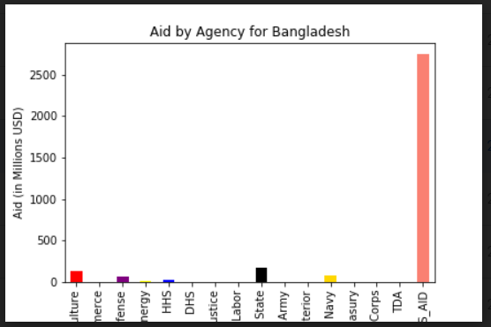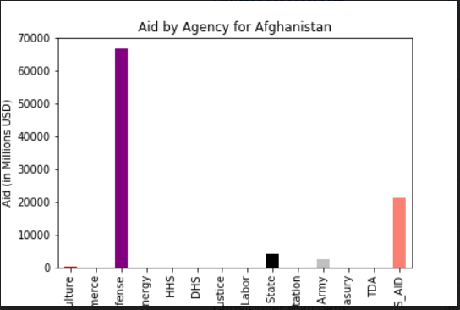

**What are the sources of US foreign aid ?**

When looking at the types of foriegn aid given out we were only able to break down US aid by the government department distributing it. Those distinctions did not exist for our world aid data. Anyone familiar with US Politics would agree that aid distributions follow a very predictable trend. While looking through the roughly 50 countries involved in this study it was clear that the middle east was receiving aid primarily from the department of defense and other military departments while countries of the global south received aid from US Agency for International Development (USAID). A surprise finding although not pertinent to our research but interesting nevertheless is the aid given to Russia.

This chart shows that the US is giving Russia Foreing Aid directly from the Department of Defense which Suggests that we are giving a perceived adversary military aid. More research into types of foreign Aid and exactly what those funds are being used for would be necessary to draw any further conclusions. 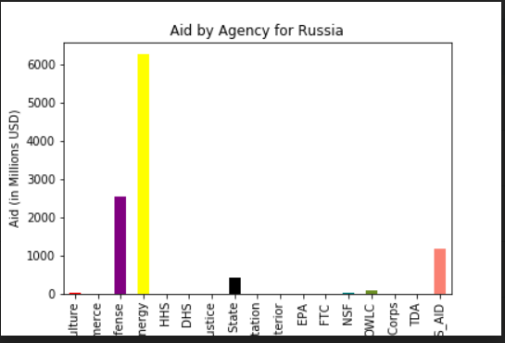

**Does the type of aid impact HDI or GDP?**

The central question to this research was about whether or not increasing aid affected Human Development Index within a country. Do to time constraints we were only able to run test statistics on our data sets as a whole. Given more time we could analyze each country correlations individually which would give us a more precise, case by case analysis on the effect that aid as on HDI and GDP. Kenya is an example of a country where this may be the case.

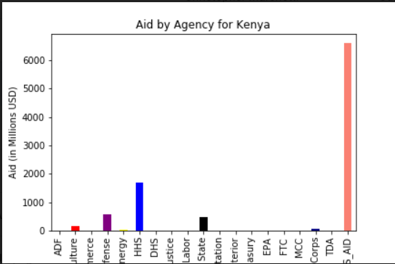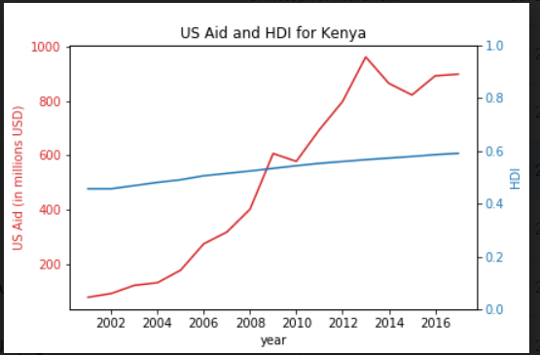

The chart on the Left is indicating that the majority of Kenya's Aid is coming from the Agency for International Development. And the line graph on the right suggests a correlation between aid and HDI. Many cases like this were evident throughout our analysis which suggests that type of aid is the most important factor in whether or not Foriegn Aid is affecting Human Development Index.

To better understand the relationship between Aid and GDP more analysis is necessary. Specifically we would need to control for variations in population sizes as countries like India have far more people than Bangladesh and the Global South. To accomplish that we would need GDP per capita data so we could accurately assess the relationship. Overall this was an insightful project that certainly opened the doors for further investigations and analysis.